**Use Cases:**

|  |  |
| --- | --- |
| **Use Case #1** | **Sort Players** |
| **Actor:** | User |
| **Description:** | It allows the user to sort the list of players alphabetically. |
| **Preconditions:** | The system has a list of players. |
| **Postconditions:** | The list of players is sorted alphabetically. |
| **Main Flow** | |
| 1. User selects the option to sort players. | |
| 1. System retrieves the list of players. | |
| 1. System performs sorting algorithm (e.g. Quicksort) recursively. | |
| 1. Sorted list is displayed on the screen. | |

**Diagram #1**

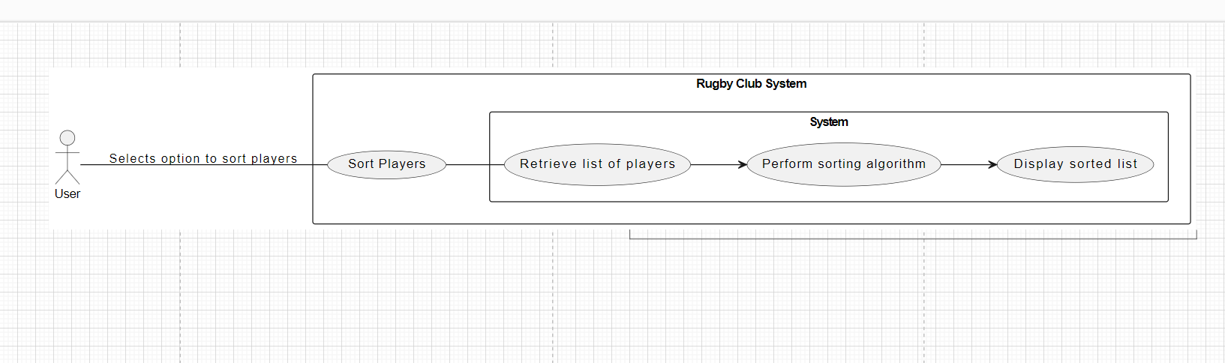

|  |  |
| --- | --- |
| **Use Case #2** | **Search Players** |
| **Actor:** | User |
| **Description:** | It enables the user to search for players by name and retrieve their coach type and team name. |
| **Preconditions:** | The system has a list of players. |
| **Postconditions:** | The relevant information (coach type and team name) of the searched player is displayed. |
| **Main Flow** | |
| 1. User selects the option to search players. | |
| 1. User inputs the name to search. | |
| 1. System retrieves the list of players. | |
| 1. System performs searching algorithm (e.g., Binary Search). | |
| 1. Relevant information is returned and displayed. | |

**Diagram #2**

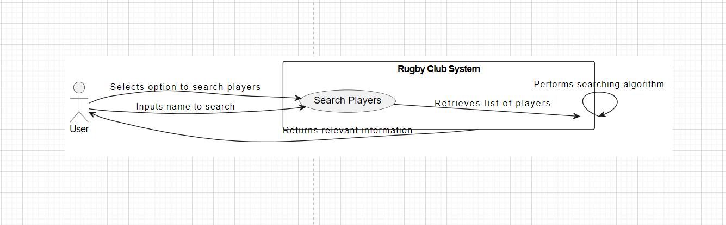

|  |  |
| --- | --- |
| **Use Case #3** | **Add Player** |
| **Actor:** | User |
| **Description:** | It allows the user to add a new player to the system by providing player name, coach type, and team. |
| **Preconditions:** | The system is running and has available coach types and teams. |
| **Postconditions:** | The new player is added to the system. |
| **Main Flow** | |
| 1. User selects the option to add a player. | |
| 1. User inputs player name, coach type, and team. | |
| 1. System validates user inputs. | |
| 1. New player data is added to the list. | |
| 1. Updated list is displayed on the screen. | |

**Diagram #3**

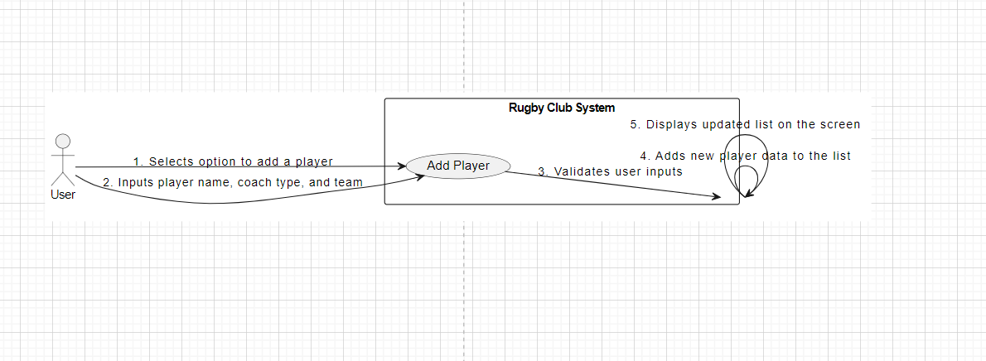

|  |  |
| --- | --- |
| **Use Case #4** | **Generate Random Players** |
| **Actor:** | User |
| **Description:** | It enables the user to generate random players with random coach types and teams. |
| **Preconditions:** | The system is running. |
| **Postconditions:** | Random players are added to the system without conflicting with existing coach types and teams. |
| **Main Flow** | |
| 1. User selects the option to generate random players. | |
| 1. System generates random player data. | |
| 1. System ensures no conflicts with existing coach types and teams. | |
| 1. Generated players are added to the system. | |
| 1. Updated list is displayed on the screen. | |

**Diagram #4**

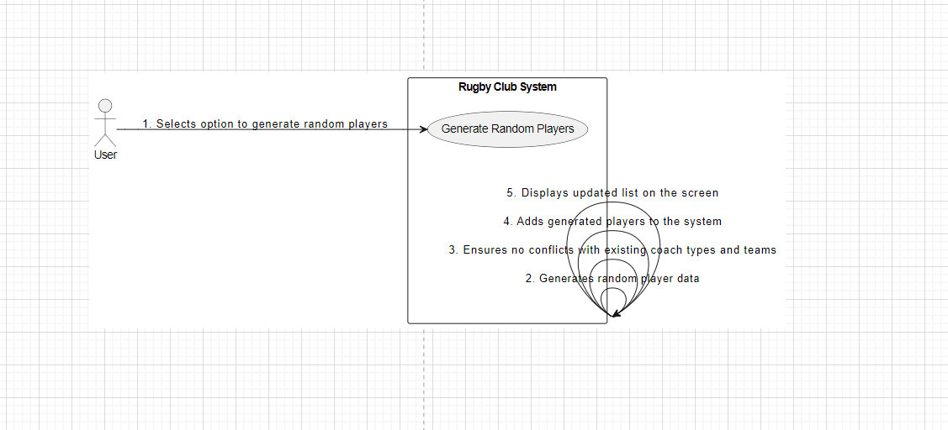

|  |  |
| --- | --- |
| **Use Case #5** | **Validate Player Input** |
| **Actor:** | System |
| **Description:** | It ensures that user input for adding a player is valid by checking the existence of coach type and team. |
| **Preconditions:** | User inputs player data for adding a player. |
| **Postconditions:** | User input is validated, and errors are handled appropriately. |
| **Main Flow** | |
| 1. System receives user input for adding a player. | |
| 1. System checks the existence of coach type and team. | |
| 1. If valid, player data is added to the system. If not, appropriate error message is displayed. | |

**Diagram #5**

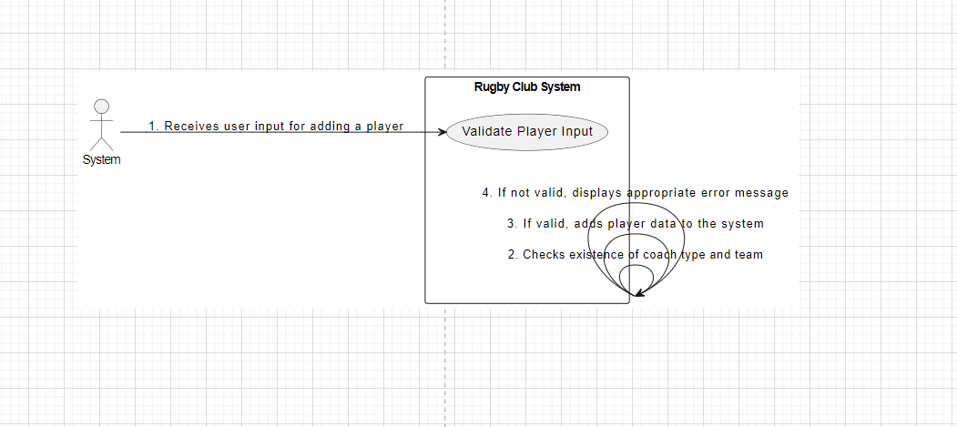

**UML Modeling Techniques:**

**1. Use Case Diagram:**

A Use Case Diagram provides a high-level view of the system's functionality and the interactions between actors (users) and the system.

**Use Case Diagram for Rugby Club System:**

**Diagram#6**

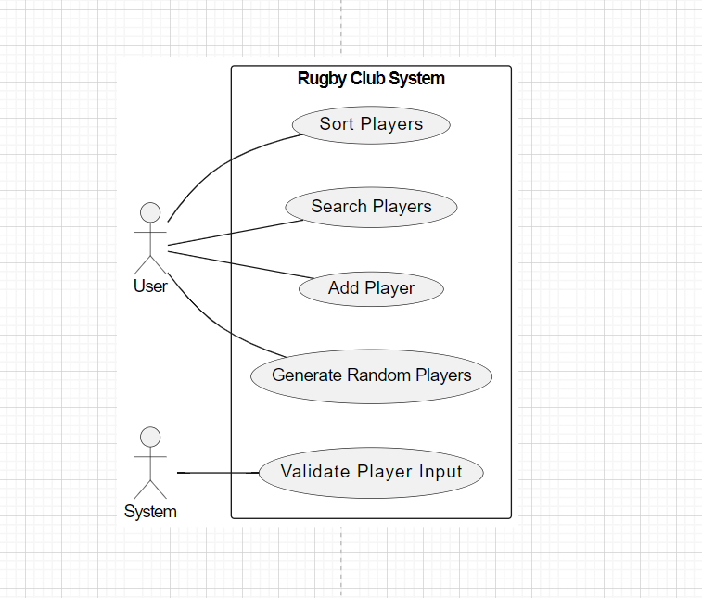

**Explanation:**

**Actors:**

**User (U):** Represents the user interacting with the system.

**System (S):** Represents the system itself.

**Use Cases:**

**Sort Players:** Allows the user to sort the list of players.

**Search Players:** Enables the user to search for players by name and retrieve their coach type and team name.

**Add Player:** Allows the user to add a new player to the system.

**Generate Random Players**: Enables the user to generate random players with random coach types and teams.

**Validate Player Input:** Ensures that user input for adding a player is valid by checking the existence of coach type and team.

**2. Activity Diagram:**

An Activity Diagram models the flow of activities or actions within a use case, showing the sequence of steps involved in performing a task.

**Activity Diagram for Rugby Club System:**

**Diagram#7**

**Explanation:**

**Steps:**

* **User Selects Add Player Option:** The user selects the option to add a new player to the system.
* **User Inputs Player Name, Coach Type, and Team:** The user provides the necessary details for the new player, including name, coach type, and team.
* **System Validates User Inputs:** The system validates the user inputs to ensure they are valid.
* **Add Player Data to System:** If the inputs are valid, the system adds the new player data to the system.
* **Display Updated Player List on Screen**: The system displays the updated list of players on the screen.

These models provide a comprehensive view of the Rugby Club System's functionality and the flow of activities within specific use cases, helping to understand the system's behavior and interactions.

**Factors to consider while selecting Use Case and Activity Diagram as modeling techniques:**

|  |  |
| --- | --- |
| **Use Case Diagrams** | |
| **High-level System Understanding:** | Use Case Diagrams provide a high-level view of system functionality and user interactions. In the context of the Rugby Club System, this diagram effectively captures the core functionalities such as sorting players, searching players, adding players, generating random players, and validating player input, aligning well with the system's requirements. |
| **Actor-System Interactions:** | Use Case Diagrams clearly depict the interactions between actors (users) and the system. In the case of the Rugby Club System, actors like "User" and "System" are identified, and their interactions with system functionalities are illustrated. This representation is essential for understanding how users interact with the system to accomplish specific tasks. |

|  |  |
| --- | --- |
| **Activity Diagram** | |
| **Detailed Process Flow:** | Activity Diagrams provide a detailed view of the sequential steps involved in performing a specific task or use case. For example, in the "Add Player" use case, the Activity Diagram delineates each step from user input to system validation and data addition, providing a clear and detailed process flow. This level of detail is crucial for understanding the intricacies of system functionality. |
| **Visual Representation of Flow:** | Activity Diagrams offer a visual representation of the flow of activities within a use case, making it easier to comprehend complex processes. In the context of the Rugby Club System, activities such as user input validation and data addition are visually represented, aiding in understanding the system's behavior and logic. |

**Comparison**

|  |  |  |  |
| --- | --- | --- | --- |
| **Use Case Diagram** | **Sequence Diagram** | **Activity Diagram** | **State Diagram** |
| Provide a high-level overview of the system's functionality and user interactions, focusing on system capabilities and user goals. | Offer a detailed view of the interactions between objects (actors or components) in the system, showing the sequence of messages exchanged between them. | Represent the flow of activities or actions within a use case, showing the sequence of steps involved in performing a task. | Model the behavior of individual objects or components in the system, emphasizing their states and transitions between states. |
| Emphasize interactions between actors (users) and the system, illustrating how users interact with system functionalities to achieve specific goals. | Emphasize dynamic behavior and temporal ordering of interactions, suitable for modeling specific scenarios or user actions in detail. | Emphasize sequential logic and decision points, suitable for modeling detailed processes with multiple steps and decision branches. | Suitable for modeling systems with discrete states and state transitions, such as systems with complex state-based logic or finite state machines. |
| Suitable for capturing system requirements and core functionalities, making them ideal for representing features such as sorting players, searching players, adding players, etc., in the Rugby Club System. | Can become complex, especially in systems with numerous interactions or complex message flows, potentially leading to cluttered diagrams that are difficult to comprehend. | Provide a clear and visual representation of process flows, aiding in understanding the sequence of actions and decision points within a use case. | Can become complex, especially in systems with numerous states and transitions, potentially leading to diagrams that are difficult to interpret or maintain. |
| **Conclusion**  In conclusion, Activity and Use Case Diagrams were chosen for modeling the Rugby Club System due to their suitability for capturing high-level system functionality, user interactions, and detailed process flows. While Sequence and State Diagrams offer valuable insights into interactions and state-based behavior respectively, they may not be the most appropriate for modeling the core features and user interactions of the Rugby Club System | | | |

**Why Activity and Use Case Diagrams were Chosen:**

* **High-Level System Understanding:**

**Use Case Diagrams:** Provide a high-level overview of system functionality and user interactions, effectively capturing core features such as sorting players, searching players, adding players, etc.

**Activity Diagrams:** Offer a detailed representation of the sequential steps involved in performing specific tasks, aiding in understanding detailed process flows within a use case.

* **User Interaction Emphasis:**

Both Activity and Use Case Diagrams emphasize interactions between users and the system, highlighting how users interact with system functionalities to achieve specific goals such as adding players, searching players, etc.

* **Clarity and Visualization:**

Activity Diagrams provide a clear and visual representation of process flows, making it easier to understand the sequence of actions and decision points within a use case.

Use Case Diagrams offer a visual representation of system functionality and user interactions, aiding in the comprehension of high-level system behavior.

* **Comprehensiveness and Balance:**

The combination of Use Case and Activity Diagrams offers a comprehensive view of the system, providing both high-level overviews of system functionality and detailed process flows within specific use cases.

**Why Sequence and State Diagrams were Not Chosen:**

* **Complexity and Detail:**

Sequence Diagrams offer a detailed view of object interactions and message flows, which may introduce unnecessary complexity for capturing the core features and user interactions of the Rugby Club System.

State Diagrams model state-based behavior and transitions, which may not be directly applicable to representing the core functionalities and user interactions of the Rugby Club System, leading to diagrams that are overly detailed and complex.

* **Focus on Dynamic Behavior:**

Sequence Diagrams emphasize dynamic behavior and temporal ordering of interactions, which may not be the primary focus when modeling high-level system functionality and user interactions.

* **Limited Relevance:**

While Sequence and State Diagrams offer valuable insights into interactions and state-based behavior, they may not directly align with the core features and user interactions of the Rugby Club System, making them less suitable for modeling its functionality.

**Summary**

In summary, Activity and Use Case Diagrams were chosen as they offer a balanced approach to modeling the Rugby Club System, effectively capturing both high-level system functionality and detailed process flows within specific use cases, while Sequence and State Diagrams may introduce unnecessary complexity or may not directly align with the system's core features and user interactions.

**User Stories:**

**User Story 1:** As a coach, I want to be able to search for players by name so that I can view their coach type and team.

**Acceptance Criteria:**

* When I search for a player by name, the system should display their coach type and team name.
* If the player is not found, the system should display a message indicating that the player is not in the system.

**Acceptance Tests:**

* Given I am a coach searching for a player named "John Doe."
* When I search for the player by name
* Then the system should display "John Doe" with coach type and team name.
* Given I am a coach searching for a player named "Jane Smith."
* When I search for the player by name
* Then the system should display a message indicating that "Jane Smith" is not in the system.

**Unit Tests:**

* Test that the search functionality retrieves the correct player information.
* Test that the search functionality handles cases where the player is not found.

**User Story 2:** As a coach, I want to be able to add a new player to the system.

**Acceptance Criteria:**

* When I add a new player with valid information, the player should be added to the system.
* If I provide invalid information, the system should display an error message.

**Acceptance Tests:**

* Given I am a coach adding a new player with valid information.
* When I input the player's name, coach type, and team.
* Then the system should add the player to the system.
* Given I am a coach adding a new player with invalid information.
* When I input invalid information
* Then the system should display an error message.

**Unit Tests:**

* Test that the system correctly adds a new player with valid information.
* Test that the system displays an error message for invalid information.

**User Story 3:** As an administrator, I want to generate random players with random coach types and teams.

**Acceptance Criteria:**

* When I generate random players, they should have unique names and random coach types and teams.
* The generated players should be added to the system without conflicts with existing coach types and teams.

**Acceptance Tests:**

* Given I am an administrator generating random players.
* When I select the option to generate random players
* Then the system should add randomly generated players to the system.

**Unit Tests:**

* Test that the system generates random players with unique names.
* Test that the system adds the randomly generated players without conflicts with existing coach types and teams.

**User Story 4:** As a user, I want to be able to sort the list of players alphabetically.

**Acceptance Criteria:**

* When I choose to sort the list of players, the system should display the players in alphabetical order.
* The sorting algorithm should efficiently organize the player list.

**Acceptance Tests:**

* Given I am a user choosing to sort the list of players.
* When I select the option to sort
* Then the system should display the players in alphabetical order.

**Unit Tests:**

* Test that the sorting algorithm correctly sorts the player list alphabetically.
* Test the efficiency of the sorting algorithm for a large player list.

**User Story 5:** As a coach, I want to be able to validate player input before adding them to the system.

**Acceptance Criteria:**

* When I input player information, the system should validate the coach type and team.
* If I provide invalid coach type or team, the system should display an error message.

**Acceptance Tests:**

* Given I am a coach providing valid player information.
* When I input the player's name, coach type, and team.
* Then the system should validate the information and add the player to the system.
* Given I am a coach providing invalid player information.
* When I input invalid coach type or team
* Then the system should display an error message.

**Unit Tests:**

* Test that the system correctly validates player input with valid information.
* Test that the system displays an error message for invalid coach type or team.